**Probability Basics**

**Probability** is the measure of how likely an event is to occur. It ranges from **0 to 1**, where:

* **0** means the event will never happen.
* **1** means the event is certain to happen.

The formula for probability is:

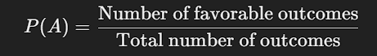

### **Types of Probability**

1. **Classical Probability** – Based on equally likely outcomes.
   * Example: Probability of rolling a 6 on a fair die = ⅙.
2. **Empirical Probability** – Based on experiments or past data.
   * Example: If it rained on 30 out of 100 days, the probability of rain tomorrow is 30\100=0.3.
3. **Subjective Probability** – Based on personal judgment or experience.
   * Example: A doctor estimating a patient’s recovery chances.

### **Example in Python**

You can use Python’s random module to simulate probability:

import random

# Simulate rolling a die 10000 times

trials = 10000

success = sum(1 for _ in range(trials) if random.randint(1, 6) == 6)

# Estimate probability

print("Estimated Probability of rolling a 6:", success / trials)